**BSC 2011 Laboratory**



Invertebrate Diversity

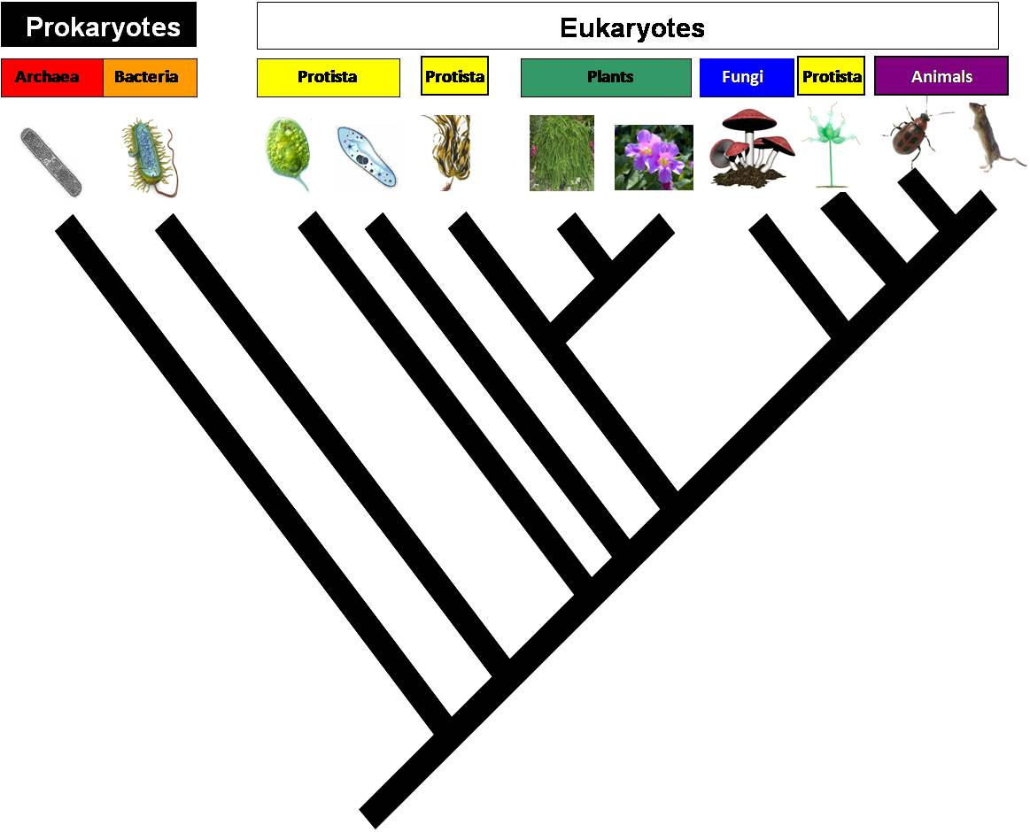

Modern ***systematics*** organizes life in a hierarchy based on available evidence for shared ancestry. The hierarchy is composed of groups that reflect increasing degrees of similarity. These groups include ***Domain***, ***Kingdom, Phylum, Class, Order, Family, Genus*** and ***Species***. This classification culminates in an organism’s ***binomial***, which is a name created by combining both its genus and species group (e.g., *Homo sapiens*).

The Kingdom Animalia (also known as the ***Metazoa***) is a monophyletic group that is thought to have derived from an ancestral flagellated protist. A long history of systematic work based on morphology and developmental traits has been used to build a ***phylogeny.*** More recently, molecular research has been used to build a phylogeny of the Metazoa. These phylogenies do not entirely match – a great example of how science works! What we thought we knew is confronted with new evidence that has also been carefully collected and verified. These discrepancies must be reconciled based on the combined evidence. The two phylogenies represent a current debate in the science of biology (it's a great time to be a biologist!). Which one is correct?

**OBJECTIVES**

In today's lab, you will:

1. (with a partner and then your table) compare (i.e., find similarities) and contrast (i.e., find differences) the morphological and molecular phylogenies.
2. (with a partner) examine some evidence for the morphological & developmental phylogeny, based on selected major phyla only.

Before you begin, it will help to be familiar with terminology. Read and refer to the glossary on the next page before you begin, and refer to it during lab – the lab will be easier if you can use the terms.

**GLOSSARY**

**Acoelomate**: a body plan without a body cavity. Each of three germ layers occur in order (ectoderm then mesoderm then endoderm) with no body cavity in between.

**Annelida**: a large phylum (~17,000 species) composed of segmented worms, where some organs repeat in segments. Includes earthworms, leeches, polychaete worms, and other groups.

**Arthropoda**: the most diverse phylum (~1 million species, >80% of described living species). All members have jointed appendages, an exoskeleton, and a segmented body. Includes Subphylum Chelicerata (e.g., spiders, scorpions, horseshoe crabs), Subphylum Myriapoda (e.g. centipedes, millipedes), Subphylum Hexapoda (e.g., insects), and Subphylum Crustacea (e.g., crabs, crayfishes and lobsters, shrimps, barnacles, copepods).

**Bilateral symmetry**: An organism with a left side and a right side. There is only one way to cut these organisms in half and obtain two matching halves. For example, humans exhibit a bilateral body plan. Also see radial symmetry.

**Chordata**: a phylum of ~44,000 species, all of which share a notochord (rod adjacent to the nerve cord) and pharyngeal gill slits at some developmental stage. They also share a hollow dorsal nerve cord and a post-anal tail. Examples include all vertebrate classes (including humans) plus less familiar groups (tunicates, cephalochordates).

**Cnidaria**: A diploblastic phylum of >9,000 aquatic species, all distinguished by stinging cells (cnidocytes). Includes jellyfish, *Hydra*, anemones, and corals.

**Coelomate**: a body plan with a membrane-lined (mesoderm) body cavity, permitting more organization than the other two body plans (acoelomate and pseudocoelomate).

**Deuterostomia**: a mode of development of the digestive system during which the mouth forms second (anus first). Also see Protostomia.

**Diploblastic**: tissues derived from two embryonic layers: ectoderm and endoderm.

**Ecdysozoa**: organisms that molt (shed an exoskeleton and grow before the next exoskeleton hardens).

**Echinodermata**: A phylum of ~7,000 marine species including starfish, brittle stars, sea urchins, sand dollars, sea cucumbers, and crinoids.

**Ectoderm**: the outer layer of tissue in the gastrula, gives rise to the skin and nervous system.

**Endoderm**: inner layer of tissue in the gastrula, gives rise to most of the digestive system and multiple internal organs.

**Eumetazoa**: organisms with true tissues. Tissue organization requires major organizational, genetic, and developmental processes.

**Lophotrochozoa**: A clade of organisms that share one of two characteristics: Either a lophophore (whorl of tentacles) mouthpart or a trochophore (ciliated, planktonic) larval stage.

**Mesoderm**: the layer of germ tissue that fills the space between ectoderm and endoderm. In triploblastic animals, the mesoderm gives rise to muscles and organs in between the endoderm and ectoderm.

**Mollusca**: A diverse phylum (~93,000 species), all of which have a large cavity used for breathing and excretion and lined with a tissue (“mantle”), and 2 or 3 nerve cords. Major Classes include gastropods (e.g., snails, slugs), bivalves (clams, mussels), and Cephalopoda (squids, octopuses).

**Nematoda**: typically small, narrow worms, >80,000 described species (an underestimate), ~1/5 are parasitic. Very numerous and ubiquitous. Complete gut, longitudinal muscles only.

**Parthenogenesis**: A type of asexual reproduction in which females produce offspring from unfertilized eggs.

**Platyhelminthes**: an acoelomate phylum of ~20,000 species without circulatory or respiratory organs. Many are important human or animal parasites. Three entirely parasitic classes are Cestoda (tapeworms), Trematoda (flukes) and Monogenea. Non-parasitic groups are in Turbellaria (e.g., the genus *Planaria*).

**Porifera**: Informally known as sponges. They lack true tissues; instead, they are composed of several different cell types. The phylogeny of sponges is currently under debate since there are conflicting molecular data studies. Some studies show porifera to be monophyletic and other studies show porifera to be paraphyletic.

**Protostomia**: a mode of development of the digestive system during which the mouth forms first (anus second). Also see Deuterostomia.

**Pseudocoelomate**: a body plan with a body cavity that is not membrane-lined by mesoderm tissue.

**Radial symmetry**: like an apple pie, the organism can be cut in half in any direction to obtain two matching halves. For example, a jellyfish has radial symmetry. Also see bilateral symmetry.

**Rotifera**: a phylum of tiny aquatic pseudocoelomates with cilia surrounding the mouth that appear to rotate when beating. This phylum comprises almost 2,000 species divided into two main groups, with diverse shapes.

**Triploblastic**: Having tissues derived from all three embryonic layers: ectoderm, mesoderm, and endoderm.

**STEP 1. Examine representatives of major invertebrate phyla**

Examples of nine major invertebrate phyla are stationed around the room for you to examine, using the directions below. You and your lab partner can move between stations in any order (you do not have to start at #1), but you will need to examine all the organisms to collect information.

Do not remove preserved or dried or live organisms from a station – other people need to see them too. Some of the stations include prepared slides and/or materials for you and your lab partner to make a wet mount slide. A microscope will be located at those stations.

Complete the tables below as you work through the stations. You are collecting data on the morphological basics of the phyla, but you should notice that most phyla remain the same in the molecular phylogeny; the traits apply regardless of the phylogeny.

|  |  |  |
| --- | --- | --- |
| **Organisms to examined in this Lab:** | | |
| **Preserved/Dried Specimens** | **Prepared Slides** | **Live Animals** |
| Yellow Sponge | Sponge slides | *Planaria* |
| Venus Flower Basket | *Obelia* medusa and polyps | Rotifers |
| *Aurelia* (Jellyfish) | *Hydra* | Leeches |
| *Taenia* | *Planaria* | Crayfish |
| Earthworms | *Clonorchis* | Bessbugs |
| *Asterias* (Starfish) | *Taenia* | Snail |
| Various Echinoderms |  | Earthworm |
| Clam and snail shells |  | Vinegar Eel |
| Squid, octopus |  | Freshwater mussel |

**Station 1. Porifera**

Identify each letter in the diagram below based on of each of the following structures; ***osculum****,* ***epidermis****,* ***porocyte****,* ***amoebocyte****,* ***choanocytes,*** and ***spicules***. Fill in the chart below with the name and function of each structure.

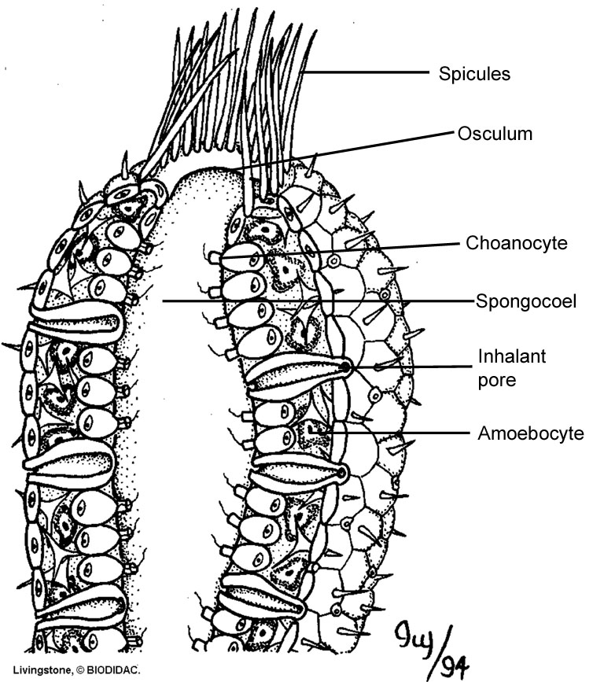

F

E

D

C

B

A

Sponge “skeletons” are composed of spicules, structures formed from calcium carbonate (*Grantia*) or silica. These provide support and aid in protecting sponges from predators. Sponges lack true tissues. The four classes of sponge are distinguished by their spicules. The Calcarea have calcium carbonate spicules, which are arranged relatively simply and may protrude from the body. Calcareous sponges are marine, and they live as single individuals or as a colony of individuals linked at their bases. Hexactinellida (or Silicea) have six-rayed spicules made of silica. The sponges are cylinder or vase shaped with spicules that are arranged in a lattice-like configuration. Hexactinellid sponges live in deep, cold, marine waters. Members of the Demospongiae have siliceous spicules with 1-4 rays. Some species of Demospongiae are lacking spicules. Members of the Sclerospongiae (Yellow sponge) have a skeleton of calcium carbonate, silica, and spongin. Sclerosponges are coralline sponges and are mostly known from fossils. The few extant species only occur on coral reefs in the West Indies and Pacific Ocean, where they help build the reef structure.

|  |  |  |
| --- | --- | --- |
| **Structure** | **Name** | **Function** |
| **A** |  |  |
| **B** |  |  |
| **C** |  |  |
| **D** |  |  |
| **E** |  |  |
| **F** |  |  |

**Station 2. Cnidaria**

Unlike sponges, which lack true tissues, all ***eumetazoans*** have true tissues derived from embryonic germ layers. ***Diploblastic*** animals, such as the Cnidaria, have two germ layers: ectoderm and endoderm. Cnidarians possess a simple body plan. Beginning with the inner most layer, the cnidarian body plan is composed of a gastrovascular cavity where digestion occurs. Both ingested and egested food travel through the same single opening into the gastrovascular cavity. The gastrovascular cavity is lined with a layer of tissue called the gastrodermis. An outer layer of cells called the epidermis is the protective outer layer of the organism. The epidermis is comprised of specialized cnidocytescontaining nematocysts. Nematocysts are organelles capable of exploding outward to discharge threads laced with neurotoxin. This neurotoxin disables prey, allowing the cnidarian to catch and consume food. The mesoglea is a thin layer of gelatinous material, located between the epidermis and the gastrodermis, which provides structural support. Examine the cnidarian cross-section below and identify the ***epidermis****,* ***gastrodermis****,* ***mesoglea***, and ***gastrovascular cavity***. **Fill in the chart below** with the name and function of each structure, as well as the germ layer from which it originated.

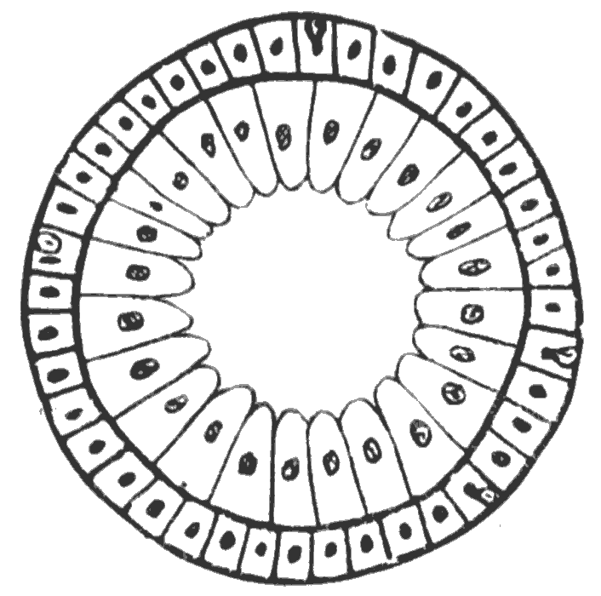

A

D

C

B

|  |  |  |  |
| --- | --- | --- | --- |
| **Structure** | **Name** | **Germ layer** | **Function** |
| **A** |  |  |  |
| **B** |  |  |  |
| **C** |  |  |  |
| **D** |  |  |  |

Two distinct stages exist within the cnidarian life cycle; a ***polyp*** and a ***medusa***. The polyp is a sessile life stage in which the organism adheres to the substrate and uses its tentacles to capture prey from the water. The medusa is a motile life stage which moves within the water column. Although the medusa can actively swim by contracting its body, it is mostly subject to the currents of the ocean. Some cnidarians exhibit only one stage in their life cycle; however, many cnidarians have complex life cycles and metamorphose between both stages. Examine the slides of *Obelia.* Is this specimen a polyp or a medusa? How can you tell? _________________________________________________________

_________________________________________________________________________________

This life stage reproduces sexually, can you see the densely stained gonad tissue within the body of *Obelia*? ________________________________________________________________________

Examine the longitudinal sketch of the *Hydra* and identify its main body parts: ***mouth****,* ***tentacle****,* ***epidermis****,* ***bud****,* and ***cnidocytes***. **Label the parts** in the drawing below.

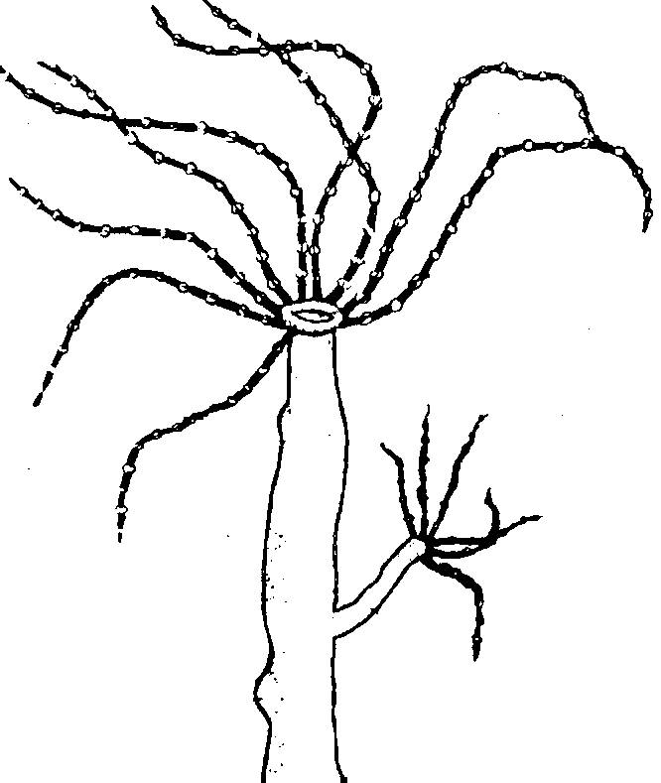

Examine the live hydra taking notice of how they bend and move. Using the prodding rod, gently prod the hydra. Do they respond to touch? ___________

Sponges do not respond to touch. What does this suggest about the nervous system of hydra compared to the nervous system of sponges? __________________________________________________________________________________

___________________________________________________________________________________

Some of the hydra are green and others are brown. What accounts for the green coloration of the hydra? ___________________________________________________________________________________

Why would this be beneficial? __________________________________________________________

**Station 3. Echinodermata**

The echinoderms (“spiny skins”) are more closely related to chordates than to any other phylum because they are also deuterostomes. However, they have a water vascular system which is a very different body plan compared to chordates. The water vascular system allows echinoderms to take water into their circulatory system and then use muscles to squeeze the water thus extending or contracting appendages. Echinoderms are diverse in species numbers and in form. You are probably most familiar with Asteroidea (starfish) or Echinoidea (sea urchins and sand dollars), but Holothuroidea (sea cucumbers) and Ophiuroidea (brittle stars) are also quite common. Examine the echinoderm specimens at the station.



How can a sea cucumber have and a starfish both have radial symmetry? ___________________

______________________________________________________________________________

Why are these organisms placed within the bilateria (organisms exhibiting bilateral symemetry)? _____________________________________________________________________________

_____________________________________________________________________________

***Body Cavity Review:***

Triploblastic animals possess one of three types of internal organization. **Coelomates** have a fluid- or air-filled body cavity, a **coelom**, located between the digestive system and the external body wall. In coelomates, the coelom is completely lined with mesoderm tissue. **Pseudocoelomates** have a fluid- or air-filled body cavity but it is lined with both mesoderm and endoderm tissue. **Acoelomates** have no body cavity.







**Station 4. Platyhelminthes**

The phylum Platyhelminthes (“flatworms”) are ***acoelomate*** worms. They are called flatworms because their bodies are dorsoventrally flattened, which increases surface area relative to volume and enables gas exchange and elimination of nitrogenous wastes by diffusion. Food is ingested and wastes are egested through the mouth, which is located at the end of a long, muscular pharynx. Members of the Class Cestoda have no digestive system of their own. They are parasitic worms that live in their host’s alimentary canal and absorb nutrients through their skin. Trematoda are flukes and are also parasitic. Of the two (Cestoda and Trematoda), the trematodes are responsible for more disease incidence worldwide.

You will examine a nonparasitic flatworm, *Planaria*. Transfer a live *Planaria* to a petri dish and, using the dissecting microscope, observe it for a few minutes.

What happens if you put obstacles in its way? _____________________________________________

__________________________________________________________________________________

What happens if you aim a bright light at it? ______________________________________________

_____________________________________________________________________________

Planarians exhibit ***cephalization*** with concentrated sensory organs towards the animal’s anterior end. Why do you think cephalization was selected as animals evolved? __________________________________________________________________________________

__________________________________________________________________________________

**Station 5. Rotifera**

Rotifers (“wheel-bearers”) are microscopic, multi-cellular animals that inhabit freshwater, oceans, and moist soil. Rotifers are **pseudoceolomates**. All rotifers have a ***corona*** of cilia at their head that draws bacteria and algae into their mouth. Rotifers have a complete digestive system with a separate mouth and anus. Rotifers are **parthenogenic** meaning populations are comprised of females that reproduce asexually. The females do produce eggs but all unfertilized eggs become females. In times of stress, many species of rotifers will shift back to sexual reproduction.

Make a wet mount of the rotifer specimen and use a compound microscope to examine them. Use the image on the next page as reference. How do they move? _____________________________________

Can you see the beating of the corona? _____________________________________________

Did you observe the rotifers consuming algae or other small organisms? _______________________

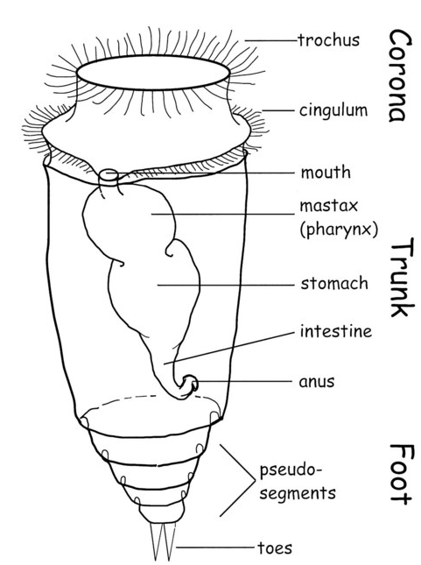

**Station 6. Mollusca**

The phylum Mollusca is ancient and very diverse: Snails, slugs, clams, scallops, squids, and octopi are the most familiar representatives. All mollusks have three main body parts: Mantle, visceral mass, and foot. This phyla is comprised of four clades: Chitons, Gastropods, Bivalves, and Cephalopods. You will be examining Gastropods, Bivalves, and Cephalopods. Gastropods include both marine and terrestrial snails and slugs. During embryonic development, their visceral mass is rotated 180° through a developmental process called torsion. Gastropods also have a single coiled shell. Bivalves are all aquatic and include clams, mussels, oysters, etc. Bivalves have shells with two hinged halves that can be opened and closed. Cephalopods are marine predators and include squid, octopus and cuttlefish. In this clade, the foot has been modified into a siphon and tentacles. The shell is reduced in size and is located internally in some species or missing completely in other species.

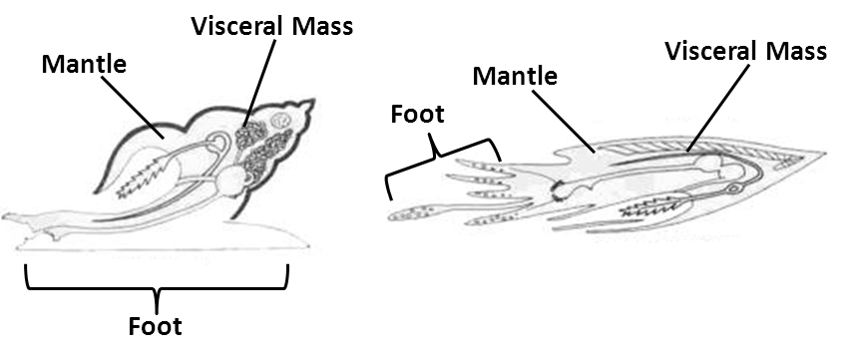

Examine the live snail and the live mussel. Identify each of the three body parts on each. Name one difference in the snail’s foot compared to the mussel’s foot ___________________________________

____________________________________________________________________________________

Examine the example clam and mussel shells compared to the example snail shell. In the space below compare how the shell of the bivalves are different than the shell of the gastropod.

_____________________________________________________________________________

_____________________________________________________________________________

Look closely at the preserved squid and octopus. They typically hunt fish and other invertebrates. List several morphological adaptations exhibited by Cephalopods (compared to the Bivalves and Gastropods) that allow them to actively hunt and capture prey.

_____________________________________________________________________________

_____________________________________________________________________________

**Station 7. Annelida**

Annelida (“little rings”) are segmented worms that inhabit marine, freshwater and moist soil habitats. Annelids are ***coelomates*** with a body plan that includes a *complete digestive system*, a *closed circulatory system*, and simple “kidneys” called *metanephridia*. Recent molecular data indicates that Annelida has two main classes: Oligochaeta and Polychaeta. Polychaetes are almost exclusively marine inhabitants. Each segment of their body has a pair of foot-like structures called parapodia. The name polychaete is derived from these parapodia: Poly = many, chaet = long hair. Oligochaetes inhabit either freshwater or soil exclusively. They include many species earthworms and leeches. Oligochaetes have fewer and shorter parapodia per body segment compared to Poloychaetes: Oligo = few, chaet = long hair.

In the figure below, identify and label the following structures: **Dorsal Vessel, Epidermis, Gastrovascular Cavity, Setae, Coelom, Metanephridia, Ventral Nerve Cord**.

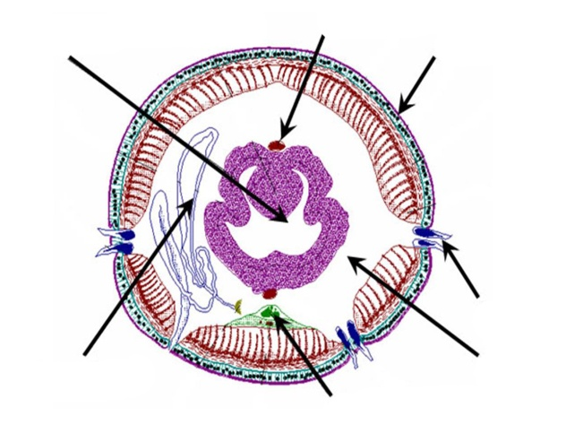

Examinethe living specimens of earthworms and leeches.

How does the earthworm move compared to the leech? ________________________________

_____________________________________________________________________________

Observe the body segments of the earthworm. Approximately how many body segments does the earthworm have? _______________________________________________________________

All annelids are coelomates, how do they differ from acoelomates such as Platyhelminthes and pseudocoelomates such as nematoda? ______________________________________________

_____________________________________________________________________________

**Station 8. Arthropoda**

Phylum Arthropoda is a large, diverse monophyletic group with more than 1 million species identified. All arthropods have a segmented body, a hard exoskeleton and jointed feet. Arthropods are ecdysozoans which mean they secrete a hard external shell that they shed as they grow. They possess a complete digestive system with a mouth and an anus. Arthropods have an open circulatory system in which their heart pumps hemolymph (blood) through sinuses surrounding body tissue. They also possess cephalization with highly organized sensory organs such eyes, antennae, and olfactory cells. The single most diverse class within this phylum is insects (Hexapoda). You will be examining two Arthropod specimens: Hexapoda (insects) and Crustacea (crustaceans). Crustaceans inhabit marine and freshwater systems, while insects are almost exclusively terrestrial with some freshwater species. Each group has developed unique adaptations in breathing, reproduction and mobility to increase success in their specific habitat. You will observe a crayfish, which is a crustacean, related to crabs and lobsters; and a bessbug, which is an insect of the order Coleoptera (beetles).

Pick up a crayfish by gently pinching its back between your thumb and forefinger. Look at its appendages, mouthparts, antennae, eyes, and body segments.

How many pairs of walking legs does the crayfish have? _______

Crayfish have a cephalothorax, which includes the head and thorax, and an abdomen. Can you identify these two body segments? _____________________________________________________________

Does it have gills? If so, where are they located? If not, how does it respire? ___________________

_________________________________________________________________________________

Watch how the crayfish moves. What does it do if confronted with an object such as a pencil? _________________________________________________________________________________

_________________________________________________________________________________

Pick up the bessbug and hold it in your hand. Look at it’s appendages, antennae, eyes, and body segments.

How many pairs of legs does the bessbug have? ___________

How is this different from the crayfish? ______________________________________________

Insects have a head, thorax and abdomen. Can you identify these three body segments? ________

Does it have gills? If yes, where are they located? If no, how does it respire? ________________

_______________________________________________________________________________

Bessbugs and crayfish are both arthropods but they live in very different habitats. What adaptations do they each exhibit that allow them to be successful in their respective habitat?

______________________________________________________________________________

**Station 9. Nematoda**

Nematodes are also ecdysozoans; creating and then shedding a hard external cuticle as they grow. Nematodes are very numerous in soils and marine sediments, and some, such as heartworms and pinworms are parasitic. Unlike annelids, they do not have segmented bodies. Molecular phylogeny aligns them with organisms such as arthropods that have a tough cuticle or exoskeleton. Like rotifers, nematodes are ***pseudocoelomates***; they have a functional body cavity derived from the embryonic blastocoel instead of a true coelom derived from mesodermal tissues. Nematodes have a complete digestive system with a separate mouth and anus, however, they lack a circulatory system.

Without a circulatory system, how do they transport nutrients, wastes and respiratory gases within the body?

_____________________________________________________________________________

Many nematodes are parasitic. How can they survive passage through and then persist in the harsh conditions of a digestive system (with its enzymes and acid)?

____________________________________________________________________________________

Nematodes move by contracting longitudinal muscles running the length of their body. This contraction produces a whip-like movement unique to nematodes. Vinegar eels are non-parasitic nematodes. They eat “Mother of Vinegar” a microbial culture of cellulose, acetic acid and bacteria that produce vinegar. Place a vinegar eel in a depression slide and observe the characteristic whip-like motion.

**STEP 2. Compare and contrast phylogenies**

With a lab partner, closely examine the two phylogenies below (these also appear on pages 663-664 in your text book). Figure 32.10 depicts a modern version of the morphological & developmental animal phylogeny. By itself, this represents the culmination of revisions through the years. Figure 32.11 depicts a consensus of recent molecular evidence (based on multiple genes).

The two phylogenies have some similarities, but some differences, too. For example, a similarity is that echinoderms and chordates are related in both phylogenies. A difference is that Porifera is monophyletic in Fig. 32.10 but comprises two monophyletic phyla (Silicea and Calcarea) in Fig. 32.11.

With a lab partner, compare and contrast the two phylogenies by writing below five more similarities (compare) and five more differences (contrast).

**Table 1.** Compare and contrast the phylogenies on the next page.

|  |  |
| --- | --- |
| Similarities | Differences |
| 1 | 1 |
| 2 | 2 |
| 3 | 3 |
| 4 | 4 |
| 5 | 5 |

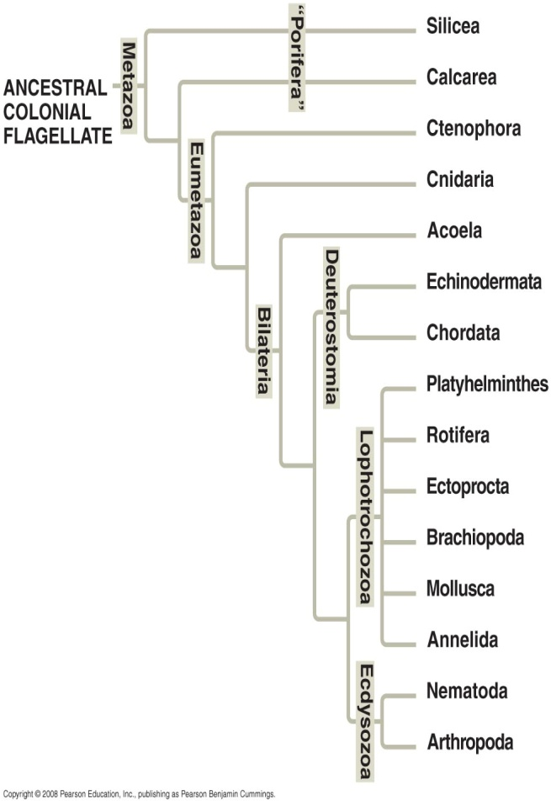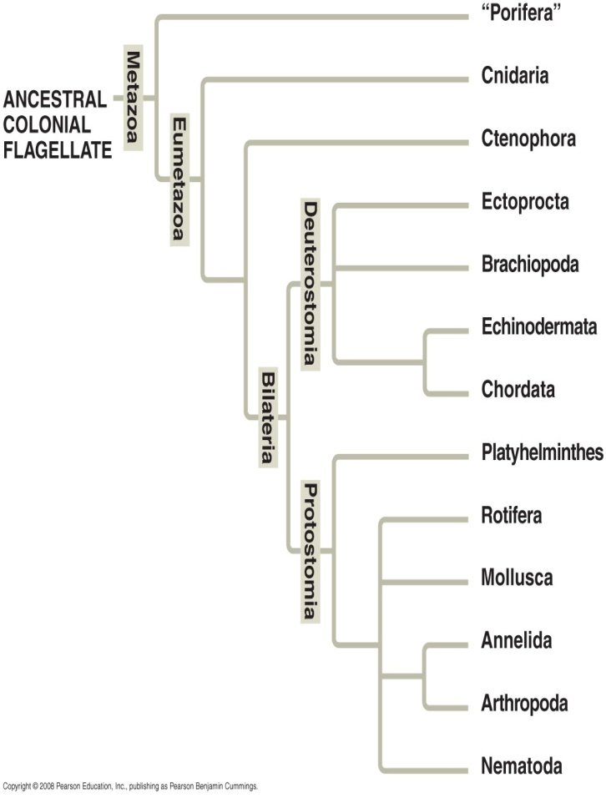

Fig 32.10. Simplified phylogeny based on Fig 32.11. Simplified phylogeny based on

morphology and developmental traits molecular traits.

After you have completed Table 1 (above), compare your answers to those of other students at your lab bench - add some of their extra similarities and differences in the space below.

|  |  |
| --- | --- |
| Similarities | Differences |
| 1 | 1 |
| 2 | 2 |
| 3 | 3 |

Future biology textbooks will show an animal phylogeny that looks more like the molecular phylogeny (Fig. 32.11) than the morphological phylogeny (Fig. 32.10). Why is it a good bet that the molecular phylogeny will probably “win” over the morphological phylogeny?